**Position Error Estimation and Compensation of 3-DOF Delta Robot under the effect of Link Tolerances**

Industrial Training Report

Date: 13/10/2021 to 10/11/2021

### *Submitted by*

**RAYYAN MUHAMMAD RAFIKH**

**REG NO: 180929124**

**&**

**DARREN ALTON DSOUZA**

**REG NO: 180929011**

**SECTION - A**

*Under the guidance of*

**DR. ANKUR JAISWAL**

**DEPARTMENT OF MECHATRONICS**

#### Manipal Institute of Technology, Manipal-576104

November 2021

**Contents**

1. Acknowledgement 2
2. Introduction 3-9
   1. Initial Breakthrough 3-5
   2. Mechanism 5
   3. Further Developments on Existing Model 5-6
   4. Applications 6-8
   5. Research Prospectus 8-9
3. Objectives 10
4. Methodology & Work 10-23
   1. Choice of Dimension 10-11
   2. 3D CAD Model of the Robot 11-12
   3. Forward Kinematic Model of the Robot 12-18
   4. Inverse Kinematic Model of the Robot 18-20
   5. Model verification through literature review & simulation using forward kinematics &/3D Model 20
   6. Effect of Tolerance 21
   7. Error Analysis 21-22
   8. Error Compensation through inverse kinematic approach 22-23
5. Inference 23
6. Conclusion 24
7. References 25
8. Annexures 26-31
9. **Acknowledgement**

I have put forth my best efforts in completing the task to guarantee that the project's quality and outcomes meet our expectations in terms of quality research.

The work behind this project was carried out together by two students - Rayyan Muhammed Rafikh (Reg. No. 180929124) and Darren Alton Dsouza (Reg. No. 180929011) under the guidance of Dr. Ankur Jaiswal, a faculty of the Mechatronics Engineering Department at Manipal Institute of Technology, Manipal, Karnataka.

I have to say indeed, that Dr. Ankur Jaiswal’s guidance has helped us have a directioned approach at each and every point of the project timeline simultaneously imparting on us his valuable knowledge on research and development aspects related to the project.

Moreover, the work was eventually converted to a research article , having been accepted by Manipal University Jaipur for the “**International Conference on Recent** **Advances in Modeling**

**and Simulations** **Techniques in Engineering and** **Science” to be held between 8-10th December 2021 in Online Mode**.

1. **Introduction**

Over the last two decades, there has been a tremendous rise in theoretical and practical research in the subject of parallel manipulators. The reasons behind this may be traced back to its more powerful, faster, and accurate system. Parallel robots offer several benefits over serial robots, including a compact structure, high stiffness, high repeated positioning accuracy, great load-bearing capability, and so on (Brinker, 2017; Xue sheng et al., 2002). As a result, it is used in tasks requiring great speed and precision [1]. However, parallel robots can have their own disadvantages, earlier research concentrated on parallel mechanisms with six degrees of freedom (DOF), which have the advantages of high stiffness, low inertia, and great payload capacity. They do, however, have the issue of a relatively limited usable workspace and design challenges. To address these challenges, a recent trend has been towards parallel manipulators with three translational degrees of freedom, which are better suited for high speed and high stiffness manipulation. In addition, the availability of closed-form systems enables exact design and efficient control. One well-known example is the Delta robot, which was developed by Reymond Clavel [2]. It is ideal for pick and place tasks with light items. Delta robots of various sizes have been adopted in several industrial applications, including the food, pharmaceutical, and electronics industries [3-6].

**2.1 Initial Breakthrough**

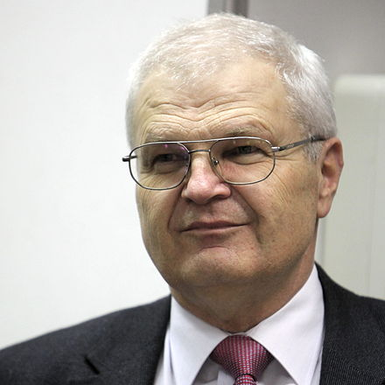

Fig.1.Reymond Clavel, director of the *Laboratoire de Systèmes Robotiques 2* at the [École Polytechnique Fédérale de Lausanne](https://en.wikipedia.org/wiki/%C3%89cole_Polytechnique_F%C3%A9d%C3%A9rale_de_Lausanne) in [Switzerland](https://en.wikipedia.org/wiki/Switzerland), inventor of the Delta Robot

Clavel's Delta robot is a four-degree-of-freedom manipulator comprised of three parallel chains linking the stationary base platform and the moving platform, each chain consisting of two arms connected through binary joints. The three chains are rotated via a 120° circular angle with regard to one another. This robot's end effector will be coupled through the centroid of the moving platform. The three upper arms are operated via the upper joints by three motors, resulting in the desired position of the moving platform and hence the end effector. The extra fourth inner leg for rigidity provides the fourth degree of freedom, and an additional rotating degree of freedom was supplied through the centroid of the fixed base platform to the end effector.

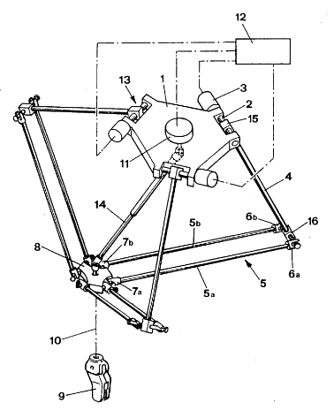

Fig.2.A Snapshot of the design included in Clavel’s U.S. Patent

Nomenclature

1 – Fixed platform

2 – Three rotating shafts

3 – Motors controlling translation of working element

4 – Arm (Upper link)

5a,5b – Linking bars (lower links)

6a,6b – Revolute Joints

7a,7b – Revolute Joints

8 – Moving platform

9 – End Effector

10 – Axis perpendicular to the moving platform

11 – Motor controlling rotation of working element

12 – Controller

13 – Three rotary actuators

14 – Telescopic arm connecting motor to working element

1. – Assembly linking control arm and rotating shaft

16 – Second extremity of the control arm

**2.2 Mechanism**

The goal of Clavel building such a mechanism was to achieve some way of manipulating an object's position in space at rapid speed while keeping the orientation unchanged. If n actuators are utilized, the end-effector of a parallel mechanism has n degrees of freedom, and the parallel mechanism is based on the parallelogram principle, which states that the output link remains in a fixed orientation relative to the input link. By introducing three of these parallel mechanisms via three chains, all three orientations of the moving platform were locked, and the moving platform could not spin in space.

**2.3 Further Developments on Existing Model**

However, this was the sole initial breakthrough in the creation of the Delta robot, both by Clavel and others, since Clavel himself ultimately brought certain advances in the mentioned Delta Robot through extra features. Furthermore, many other academics and manufacturers have advanced this three-degree-of-freedom robot to a six-axis robot, making it industry-ready by providing it with new developing technologies such as machine learning and computer vision. The current common delta robot designs differ greatly from those developed by Clavel, with even the means of actuation changing, such as prismatic input in linearly actuated Delta Robots rather than revolute input in rotating Delta Robots. Today's industrial equipment are outfitted with cutting-edge tools and operate autonomously with the assistance of artificial intelligence.

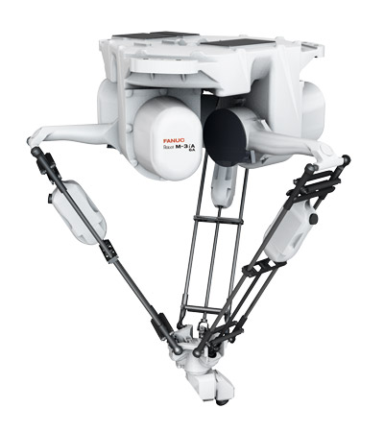

Fig.3.6-Axis, FANUC M-3*I*A/6A Delta Robot

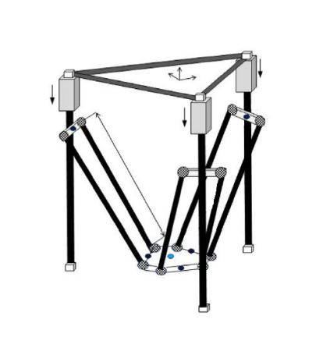

Fig.4.Linearly Actuated 3 Degree of Freedom Delta Robot

* 1. **Applications**

The Delta Robot in all its forms and advancement has increasingly been adopted in various industries with the growth of Industry 4.0 and also with the emerge of Industry 5.0. It is surprising to know that Reymond Clavel himself had begun to work on this breakthrough technological idea when after visiting a chocolate factory in Switzerland, his team member wanted some means to place pralines in their packages.

Since then, the first application of the so formed Delta Robots was as obvious in the food industry, mainly the packaging section as pick and place robots. From there on, it spread out to many other industries such as the aviation industry, where the mechanisms are used as large sized simulators. A small size application of the linearly actuated counterparts of these machines are now popular as 3D printers as well. The delta robot-based 3D printers exploit the Fused Deposition Modelling Technique for 3D printing and have many advantages over their cartesian counterparts such as speed, positioning accuracy but are limited by only one aspect which is their workspace volume.

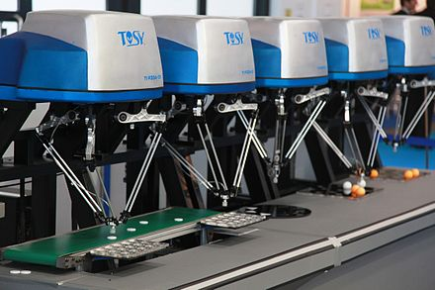

Fig.5.Pick and Place Delta Robots used in the Packaging Industry

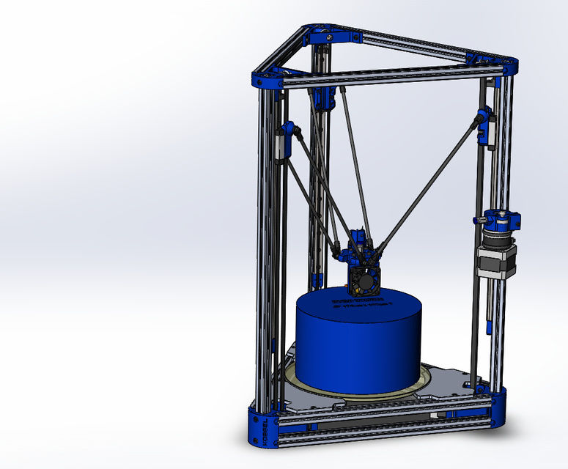

Fig.6.A Delta Robot based 3D Printer

* 1. **Research Prospectus**

There has been a great deal of quality research in this area, but more research is still needed in this field to overcome its limitations of low positioning accuracy and smaller work volume to conquer over its serial counterparts used for the same applications, as well as to be able to apply it in a much broader range of applications.

End-effector position accuracy is a key metric for assessing parallel robot performance. However, it has not yet been completely resolved [7–14]. Parallel robots are becoming faster and lighter and the parameters influencing end effector position accuracy are becoming more complicated. Scholars are now conducting extensive study in the subject of parallel robot position accuracy and compensating methods [15–18].

In this project a method is derived to reduce the maximum positional error obtained due to the manufacturing tolerances in the binary links of a spatial 3-DOF delta robot. Compensation of error was performed using inverse kinematics approach.

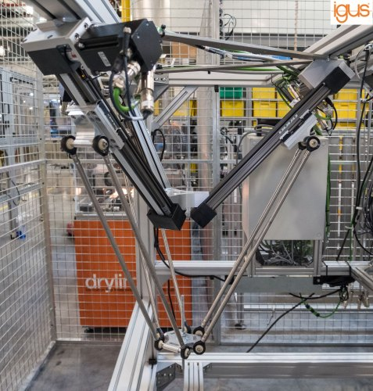

Fig.7. Delta Robot with the input joint axes tilted with respect to the base

1. **Objectives**

Inaccuracies in manufacturing of the hardware of robots is constantly becoming a cause for the low precision of the goods manufactured and the services provided in the industries where these robots are used. Hence, the errors in the manufacturing of robots could be the cause for the manufacturing errors of a wide variety of goods as these robots are used in a very wide variety of applications in an ever-increasing number of industries.

The thought of getting rid of these errors at the root level is the best but it may seem impractical as there is always some degree of error produced in the manufacturing timeline, no matter how careful we be and how better our manufacturing processes evolve in terms of precision and accuracy. Therefore, a method for eradication of the errors produced by the robots whilst the robots still not being error-free is an urgent need of the industry.

The objective of this mini project was to come up with a solution for the undesired differences in positions of the moving platform caused by the inaccurate manufacturing of the hardware of the 3 Degree of Freedom Delta Robot.

1. **Methodology and Work**

The basic path in the process of the analysis of all robots follows a very generalize route which consists of the following things:

Choice of Dimension ,3D Model of the robot, Generalized Forward kinematic model of the robot,

Inverse Kinematic model of the robot , Model verification through published research &/ code generated values using forward kinematics &/ 3D Model, Effect of Tolerance, Error Analysis,

Error Compensation through inverse kinematic approach

* 1. **Choice of Dimension**

To achieve this purpose, we needed to come up with a verified model of the Robot so that we can later introduce tolerances in the upper and lower links separately with all possible combinations. Model verification was necessary in order to proceed further with all the processes with confidence. For this, we used the model specifications which had the lengths as given below:

Fixed Platform’s distance from Centroid to Link attachment point, $R_{f}$ = 205 mm

Moving Platform’s distance from Centroid to Motor attachment point, $R_{e}$ = 50 mm

Upper link length, $l_{b}$ = 400 mm

Lower link length, $l_{e}$ = 1000 mm

The angular input range was used to generate the complete range of output cartesian configurations of the moving platform’s centroid. The input range used for each joint was $[-40°,80°]$.

**4.2 3D CAD Model of the robot**

A 3D CAD Model of the robot with the specified link lengths was made using Autodesk Fusion 360 for a better understanding of the mechanism as well for simulation purpose.

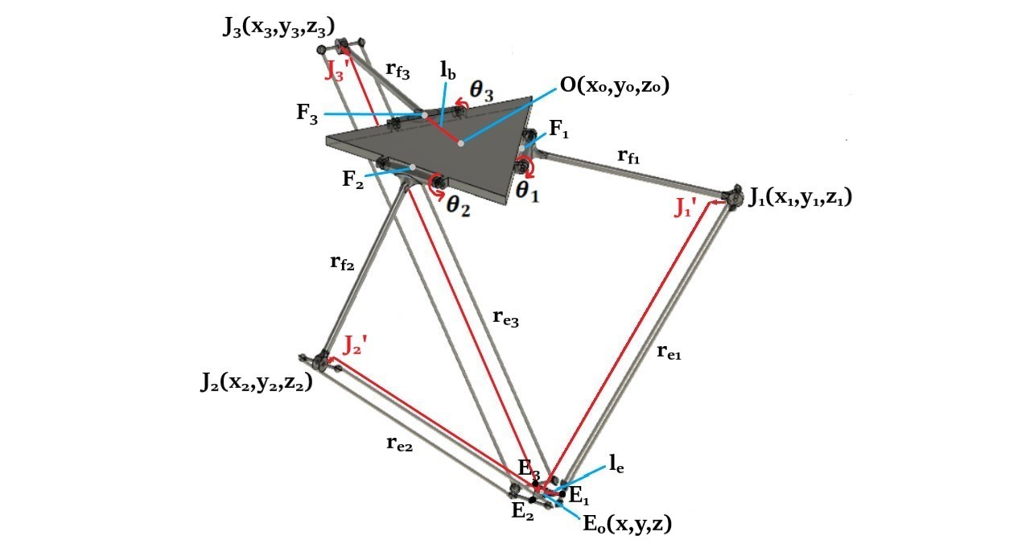

Fig.8. 3D Model of the Delta Robot made in Autodesk Fusion 360 with all the notations

* 1. **Forward kinematic model of the robot**

Next requirement was to get the forward kinematics of the delta robot so as to obtain its end-effector position. It was then formulated using the geometrical approach.

A kinematic sketch was drawn for clear understanding of the model and its respective components required inorder to formulate its direct kinematics.

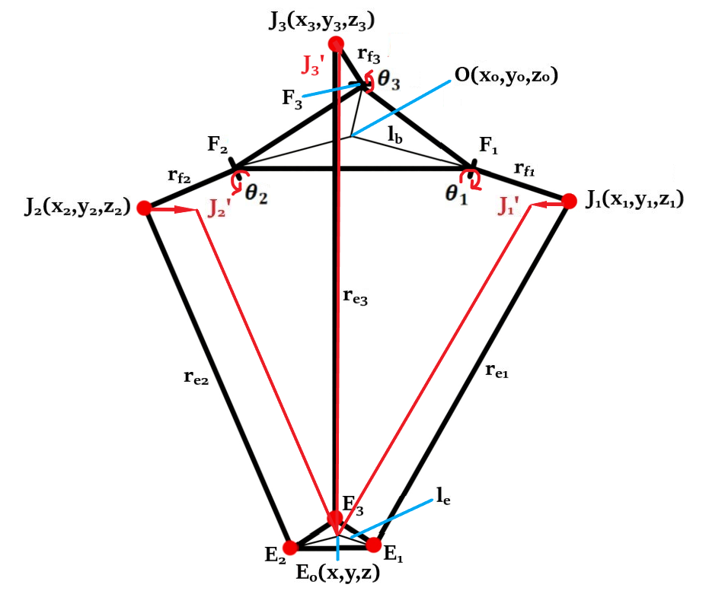

Fig.9.Kinematic Sketch of the Delta Robot

|  |  |
| --- | --- |
| **Nomenclature** | **Definition** |
| $$J_{1}^{'}$$ | Projection of point $J_{1}$ |
| $$J_{2}^{'}$$ | Projection of point $J_{2}$ |
| $$J_{3}^{'}$$ | Projection of point $J_{3}$ |
| $$x_{1}$$ | X coordinate of $J_{1}^{'}$ |
| $$y_{1}$$ | Y coordinate of $J_{1}^{'}$ |
| $$z_{1}$$ | Z coordinate of $J_{1}^{'}$ |
| $$x_{2}$$ | X coordinate of $J_{2}^{'}$ |
| $$y_{2}$$ | Y coordinate of $J_{2}^{'}$ |
| $$z_{2}$$ | Z coordinate of $J_{2}^{'}$ |
| $$x_{3}$$ | X coordinate of $J_{3}^{'}$ |
| $$y_{3}$$ | Y coordinate of $J_{3}^{'}$ |
| $$z_{3}$$ | Z coordinate of $J_{3}^{'}$ |
| $$x$$ | X coordinates of tool attachment point |
| $$y$$ | Y coordinates of tool attachment point |
| $$z$$ | Z coordinates of tool attachment point |
| $$x^{'}$$ | X coordinates of tool attachment point under tolerance |
| $$y^{'}$$ | Y coordinates of tool attachment point under tolerance |
| $$z^{'}$$ | Z coordinates of tool attachment point under tolerance |
| $$θ_{1}$$ | Joint angle 1 |
| $$θ_{2}$$ | Joint angle 2 |
| $$θ_{3}$$ | Joint angle 3 |
| $$r_{f}$$ | Upper link length |
| $$r_{e}$$ | Lower link length |
| $$l_{e}$$ | Distance between centroid of moving platform and link attachment point |
| $$l_{b}$$ | Distance between centroid of fixed platform and motor attachment point |
| $$E_{o}$$ | Centroid of moving platform |
| $$E_{1}$$ | Binary joint point between upper and lower link |
| $$F_{1}$$ | Motor attachment point |
| $$O$$ | Origin at centroid of fixed platform |

Nomenclature of the notations used and their definitions

The forward kinematics for the robot were formulated as below:

|  |  |
| --- | --- |
| Equations |  |
| $$J_{1}^{'}=( 0, -\left(l_{b}-l_{e}\right)-r_{f1}\cos{θ_{1},}-r_{f1}\sin{θ_{1}})$$ |  |
| $$J_{2}^{'}=(\left(l_{b}-le+r_{f2}\cos{θ_{2}}\right)\left(\cos{30°}\right), \left(l_{b}-le+r_{f2}\cos{θ_{2}}\right)\left(\cos{60°}\right), -r_{f2}\sin{θ_{2})}$$ |  |
| $$J_{3}^{'}=(\left(-l_{b}+l_{e}-r_{f3}\cos{θ_{3}}\right)(\cos{30°)},(l_{b}-l_{e}+r_{f3}\cos{θ_{3})}(\cos{60°)},-r_{f3}\sin{θ_{3})}$$ |  |
| $$x_{1}=0$$ | (1) |
| $$y_{1}= -\left(l_{b}-l_{e}\right)-r_{f1}\cos{θ_{1}}$$ | (2) |
| $z_{1}= -r_{f1}\sin{θ_{1}}$ | (3) |
| $$x_{2}= \left(l_{b}-le+r_{f2}\cos{θ_{2}}\right)\left(\cos{30°}\right)$$ | (4) |
| $$y_{2}= \left(l_{b}-le+r_{f2}\cos{θ_{2}}\right)\left(\cos{60°}\right)$$ | (5) |
| $$z_{2}= -r_{f2}\sin{θ_{2}}$$ | (6) |
| $$x_{3}=(-l_{b}+l_{e}-r_{f3}\cos{θ_{3})(\cos{30})}$$ | (7) |
| $$y_{3}=(l_{b}-l_{e}+r_{f3}\cos{θ_{3})(\cos{60})}$$ | (8) |
| $$z_{3}= -r_{f3}\sin{θ_{3}}$$ | (9) |
| $$x^{2}+y^{2}+z^{2}-2xx_{1}-2yy_{1}-2{zz}_{1}=r_{e1}^{2}-\left(x_{1}^{2}+y_{1}^{2}+z_{1}^{2}\right)$$ |  |
| $$x^{2}+y^{2}+z^{2}-2xx_{2}-2yy_{2}-2{zz}_{2}=r_{e2}^{2}-\left(x_{2}^{2}+y_{2}^{2}+z_{2}^{2}\right)$$ |  |
| $$x^{2}+y^{2}+z^{2}-2xx_{3}-2yy_{3}-2{zz}_{3}=r_{e3}^{2}-\left(x_{3}^{2}+y_{3}^{2}+z_{3}^{2}\right)$$ |  |
| $$w_{1}=x_{1}^{2}+y_{1}^{2}+z_{1}^{2}$$ | (10) |
| $$w_{2}=x_{2}^{2}+y_{2}^{2}+z_{2}^{2}$$ | (11) |
| $$w_{3}=x_{3}^{2}+y_{3}^{2}+z_{3}^{2}$$ | (12) |
| $$x^{2}+y^{2}+z^{2}-2xx_{1}-2yy_{1}-2{zz}_{1}=r_{e1}^{2}-w_{1}$$ | (13) |
| $$x^{2}+y^{2}+z^{2}-2xx_{2}-2yy_{2}-2{zz}_{2}=r_{e2}^{2}-w_{2}$$ | (14) |
| $$x^{2}+y^{2}+z^{2}-2xx_{3}-2yy_{3}-2{zz}_{3}=r_{e3}^{2}-w_{3}$$ | (15) |
| (13) - (14) gives us $$-x_{2}x+\left(y_{1}-y_{2}\right)\left(y\right)+\left(z_{1}-z_{2}\right)\left(z\right)=\left(\frac{w_{1}-w_{2}+r_{e_{2}}^{2}-r_{e_{1}}^{2}}{2}\right)$$ | (16) |
| (13) - (15) gives us $$-x_{3}x+\left(y_{1}-y_{3}\right)\left(y\right)+\left(z_{1}-z_{3}\right)\left(z\right)=\left(\frac{w_{1}-w_{3}+r_{e_{3}}^{2}-r_{e_{1}}^{2}}{2}\right)$$ | (17) |
| (14) - (15) gives us $$(x_{2}-x_{3})x+\left(y_{2}-y_{3}\right)\left(y\right)+\left(z_{2}-z_{3}\right)\left(z\right)=\left(\frac{w_{2}-w_{3}+r_{e_{3}}^{2}-r_{e_{2}}^{2}}{2}\right)$$ | (18) |
| From (16) $$x=\left(\frac{-\left(\frac{w_{1}-w_{2}+r_{e_{2}}^{2}-r_{e_{1}}^{2}}{2}\right)+\left(z_{1}-z_{2}\right)\left(z\right)+\left(y_{1}-y_{2}\right)\left(y\right)}{x_{2}}\right)$$ | (19) |
| $$x=\left(\frac{-\left(\frac{w_{1}-w_{3}+r_{e_{3}}^{2}-r_{e_{1}}^{2}}{2}\right)+\left(z_{1}-z_{3}\right)\left(z\right)+\left(y_{1}-y_{3}\right)\left(y\right)}{x_{3}}\right)$$ | (20) |
| Equating (19) and (20), we get $y=a_{2}z+b_{2}$ | (21) |
| Where $a_{2}=\left(\frac{x_{2}\left(z_{1}-z_{3}\right)-x_{3}\left(z_{1}-z_{2}\right)}{d_{2}}\right)$ $b_{2}=\left(\frac{-\left(x_{2}\right)\left(w_{1}-w_{3}+r_{e_{3}}^{2}-r_{e_{1}}^{2}\right)+x_{3}\left(w_{1}-w_{2}+r_{e_{2}}^{2}-r_{e_{1}}^{2}\right)}{2d_{2}}\right)$ $d_{2}=(x_{3}\left(y_{1}-y_{2}\right)-x_{2}\left(y_{1}-y_{3}\right))$ | (22)  (23)  (24) |
| From (17) $$y=\left(\frac{\left(\frac{w_{1}-w_{3}+r_{e_{3}}^{2}-r_{e_{1}}^{2}}{2}\right)-\left(z_{1}-z_{3}\right)\left(z\right)+x_{3}x}{y_{1}-y_{3}}\right)$$ | (25) |
| From (18) $$y=\left(\frac{\left(\frac{w_{2}-w_{3}+r_{e_{3}}^{2}-r_{e_{2}}^{2}}{2}\right)-\left(z_{2}-z_{3}\right)\left(z\right)-{(x_{2}-x}_{3})x}{y_{2}-y_{3}}\right)$$ | (26) |
| From (25) and (26), we get $$x=a_{1}z+b_{1}$$ | (27) |
| Where $a_{1}=\left(\frac{\left(y_{2}-y_{3}\right)\left(z_{1}-z_{3}\right)-\left(y_{1}-y_{3}\right)\left(z_{2}-z_{3}\right)}{d_{1}}\right)$ | (28) |
| $b_{1}=\left(\frac{\left(y_{1}-y_{3}\right)\left(\frac{w_{2}-w_{3}+r_{e_{3}}^{2}-r_{e_{2}}^{2}}{2}\right)-\left(y_{2}-y_{3}\right)\left(\frac{w_{1}-w_{3}+r_{e_{3}}^{2}-r_{e_{1}}^{2}}{2}\right) }{d_{1}}\right)$ $d_{1}=(x_{3}\left(y_{2}-y_{3}\right)+(x_{2}-x_{3})\left(y_{1}-y_{3}\right))$ | (29)  (30) |
| Substituting (21) and (27) in (13), we get $az^{2}+bz+c=0$   where $a=(a_{1}^{2}+a_{2}^{2}+1)$ $$b=(2a_{1}b_{1}+2a_{2}b_{2}-2a_{2}y_{1}-2z_{1})$$ $$c=(-r_{e}^{2}+y_{1}^{2}+z_{1}^{2}-2b_{2}y_{1}+b_{2}^{2}+b_{1}^{2})$$ Using the discriminant formula for quadratic equations and upon solving for x, we get $z=\left(\frac{-b-\sqrt{D}}{2a}\right)$ | (31) |
| Substituting the value of z in (21) and (27), we get x and y as $$x=a_{1}\left(\frac{-b-\sqrt{D}}{2a}\right)+b_{1}$$ $$y=a_{2}\left(\frac{-b-\sqrt{D}}{2a}\right)+b_{2}$$ |  |

These equations were then used to write a program in python which generated the cartesian coordinates of the moving platform’s centroid with high accuracy given the joint input angles as inputs within their complete range and keeping the link lengths fixed and without tolerance.

The complete range of joint angle input for each joint was divided into 30 steps which gave us a step value of $4°$ and a total number of values equal to 30 + 1 = 31 for each joint input angle, resulting in ${31}^{3}=29791$ possible number of combinations to iterate over.

The values generated through the code were appended to an excel sheet for further analysis. The excel sheet thus generated was used to plot the 3D workspace and its 2D projections of the robot in MATLAB, a snapshot of which is attached below.

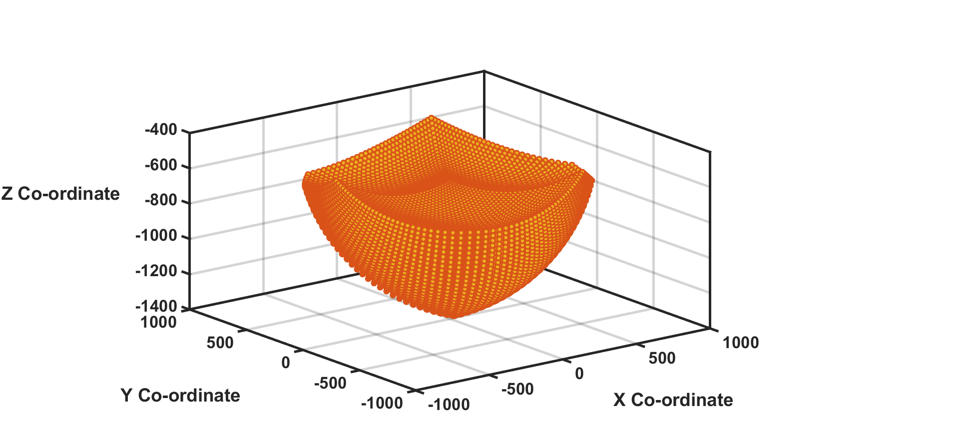

Fig.10.Workspace of Delta robot



Fig.11.XZ Plane of workspace



Fig.12.YZ Plane of Workspace

**4.4 Inverse Kinematic model of the robot**

The inverse kinematic model of the robot was needed, in our project to verify the model as well as to come up with a compensation technique to eradicate the positioning error. The same approach was used to formulate the inverse kinematics equations as well.

|  |  |
| --- | --- |
| Equations |  |
| $$E_{o}≡(x_{o},y_{o},z_{o})$$ |  |
| $$E_{1}≡(x_{o},y_{o}-l_{e},z_{o})$$ |  |
| $$E_{1}^{'}≡(0,y_{o}-l_{e},z_{o})$$ |  |
| $$F_{1}≡(0,-l_{b},0)$$ |  |
| Equation of circle with radius $F_{1}J_{1}$ and corresponding point $J_{1}$ on circumference and center as $F_{1}$ $${(y_{J1}-y_{F1})}^{2}+{(z_{J1}-z_{F1})}^{2}=r_{f}^{2}$$ $$y_{J1}^{2}+l_{b}^{2}+2y_{J1}l_{b}+z_{J1}^{2}=r_{f}^{2}$$ | (32) |
| Equation of circle with radius $J_{1}E_{1}^{'}$ and corresponding point $J_{1}$ on circumference and center as $E_{1}^{'}$ $${\left(y_{J1}-y_{E_{1}^{'}}\right)}^{2}+{\left(z_{J1}-z_{E_{1}^{'}}\right)}^{2}=r_{e}^{2}-x_{o}^{2}$$ $$y_{J1}^{2}-2y_{J1}\left(y_{o}-l_{e}\right)+z_{J1}^{2}-2z_{J1}z_{o}=r_{e}^{2}-x_{o}^{2}-z_{o}^{2}-{(y_{0}-l_{e})}^{2}$$ | (33) |
| From (32), $$z_{J1}^{2}=r_{f}^{2}-y_{J1}^{2}-l_{b}^{2}-2y_{J1}l_{b}$$ | (34) |
| Substituting (34) in (33), we get $$z_{J1}=ay_{J1}+b$$ where $$a=\left(\frac{-2l_{b}-2y_{o}+2l_{e}}{d}\right)$$ $$b=\left(\frac{-r_{e}^{2}+x_{o}^{2}+z_{o}^{2}+{\left(y_{o}-l_{e}\right)}^{2}+r_{f}^{2}-l_{b}^{2}}{d}\right)$$ $$d=2(z_{o})$$ | (35) |
| Substituting (35) in (34), we get $$a_{1}y_{J1}^{2}+b_{1}y_{J1}+c_{1}=0$$ Where $$a_{1}=a^{2}+1$$ $$b_{1}=2ab+2l_{b}$$ $$c_{1}=b^{2}+l_{b}^{2}-r_{f}^{2}$$ |  |
| Upon solving for discriminant, we get $$D=b_{1}^{2}-4a_{1}c_{1}$$ $$y_{J}=\left(\frac{-b_{1}-\sqrt{D}}{2a_{1}}\right)$$ | (36) |
| Substituting (36) in (35), we get $z_{J1}$ Then, $θ_{1}=\tan^{-1}{(\left(\frac{z_{J1}}{y_{F1}-y_{J1}}\right))}$   For finding $θ_{2}$, use $$x_{o}^{'}=x_{o}\cos{120°}+y_{o}\sin{120°}$$ $$y_{o}^{'}=y_{o}\cos{120°}-x_{o}\sin{120°}$$ For finding $θ_{3}$, use $$x_{o}^{'}=x_{o}\cos{120°}-y_{o}\sin{120°}$$ $$y_{o}^{'}=y_{o}\cos{120°}+x_{o}\sin{120°}$$ |  |

These equations were then used to write the python program for generating the joint angle values given the cartesian coordinates of the centroid of the moving platform as the input.

**4.5 Model verification through literature review & simulation using forward kinematics & 3D Model**

The programs written for both forward and inverse kinematics were eventually verified by comparing values with that of the tables given in the paper.

Moreover, the model was also verified by comparing the input of the forward kinematics program and output of the inverse kinematics program for some sets of combinations out of those 29,791 different postures.

* 1. **Effect of Tolerance**

The code written using the equations in section 4.2 was the used to generate the excel sheet of values of the forward kinematics solutions when the link lengths are under tolerance. This was achieved by setting the link lengths in the program different and not equal. The tolerance range chosen was with an error $±10 μ$ to $±100 μ$ in steps of .

* 1. **Error Analysis**

The excel sheet generated under tolerance was then used to analyze the error in the positioning of the interested point, that is the centroid of the moving platform.

For this we compared the values of the no tolerance excel sheet with the corresponding values (same joint input angles) of the tolerance excel sheet and obtained the positional error by applying the distance formula between the two points.

The comparison done was then translated to a series of plots for visual observation of the nature of deviation from the original desired plots.

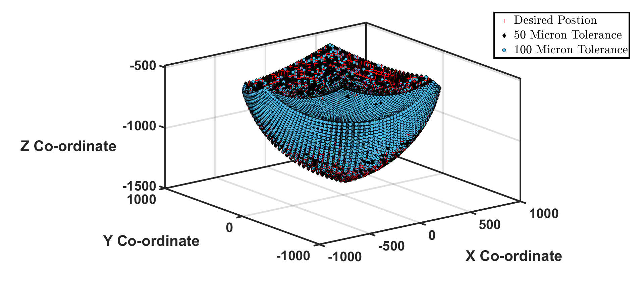

Fig.12.Desired and Deviated Condition Plot

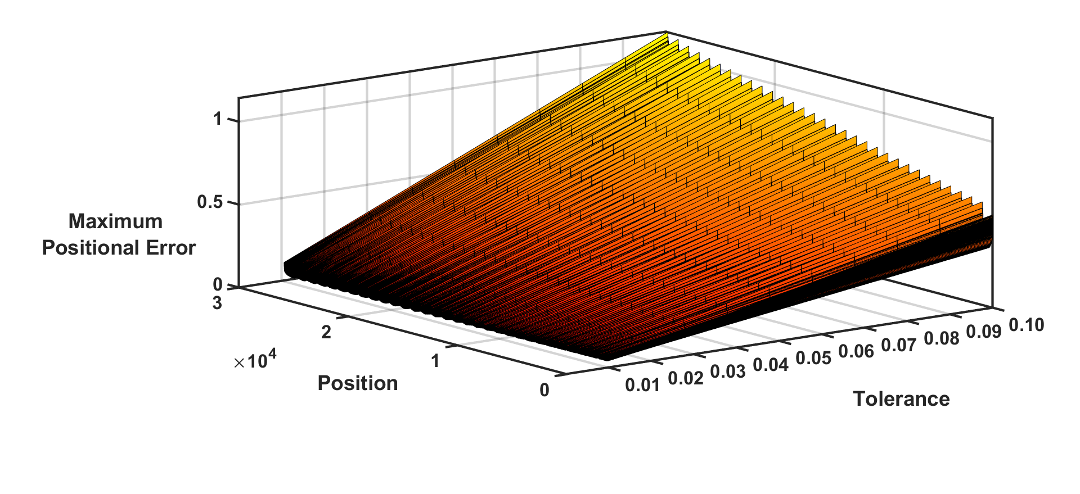

Fig.13.Desired and Deviated Condition Plot



Fig.14.Maximum Positional Error vs Tolerance Plot

It was observed that as expected, the maximum positional error was obtained when the tolerance in the all the link lengths were maximum, hence a linearity was established between the positional error and the tolerance. The position error was calculated for inputs with maximum deviation shown.

Table 1 Position error estimation under link tolerance

|  |  |  |  |  |
| --- | --- | --- | --- | --- |
| Tolerance  (in Microns) | Input Angles  𝜃1  𝜃2  𝜃3 | Desired Position of  moving planform  x y z | Deviated Position of  moving planform $x^{'}$ $y^{'}$ $z^{'}$ | Position Error |
| 10 | 80 80 80 | 0 0 -1368.40 | -0.05 -0.09 -1368.41 | 0.10 |
| 20 | 80 80 80 | 0 0 -1368.40 | 0.22 0 -1368.42 | 0.22 |
| 30 | 80 80 80 | 0 0 -1368.40 | -0.17 0.29 -1368.42 | 0.33 |
| 40 | 80 80 80 | 0 0 -1368.40 | -0.22 -0.39 -1368.43 | 0.44 |
| 50 | 80 80 80 | 0 0 -1368.40 | 0.57 0 -1368.43 | 0.57 |
| 60 | 80 80 80 | 0 0 -1368.40 | 0.68 0 -1368.44 | 0.68 |
| 70 | 80 80 80 | 0 0 -1368.40 | -0.39 0.69 -1368.45 | 0.79 |
| 80 | 80 80 80 | 0 0 -1368.40 | -0.45 -0.79 -1368.45 | 0.91 |
| 90 | 80 80 80 | 0 0 -1368.40 | 1.02 0 -1368.46 | 1.02 |
| 100 | 80 80 80 | 0 0 -1368.40 | -0.57 0.98 -1368.47 | 1.13 |

**4.8 Error Compensation through inverse kinematic approach**

The errors obtained in section 4.6 were used to come up with a solution with the help of the inverse kinematic equations formulated in section 4.3.

This provides a method for arriving at the desired posture of the centroid of the moving platform when the link lengths are under tolerance. For achieving this, we provide the inputs with an additional value $∆θ_{j}$ where $j∈$ (1,2,3).

Depicted below is the tabular values computed while performing error compensation using inverse kinematics.

Table 2 Error compensation using inverse kinematics

|  |  |  |  |
| --- | --- | --- | --- |
| Tolerance  (in Microns) | Input Angles  𝜃1  𝜃2  𝜃3 | Deviated Angles (Under Tolerance) $θ_{1}^{'}$ $θ_{2}^{'}$ $θ_{3}^{'}$ | Error Compensation $∆θ_{1}$ $∆θ_{2}$ $∆θ_{3}$ |
| 10 | 80 80 80 | 80.00 80.00 79.92 | 0.00 0.00 0.08 |
| 20 | 80 80 80 | 79.98 80.01 80.01 | -0.01 0.01 0.01 |
| 30 | 80 80 80 | 80.02 79.97 80.02 | 0.02 -0.02 0.02 |
| 40 | 80 80 80 | 80.02 80.02 79.97 | 0.02 0.02 -0.02 |
| 50 | 80 80 80 | 79.96 80.03 80.03 | -0.03 0.03 0.03 |
| 60 | 80 80 80 | 79.95 80.04 80.04 | -0.04 0.04 0.04 |
| 70 | 80 80 80 | 80.04 79.95 80.04 | 0.04 0.04 0.04 |
| 80 | 80 80 80 | 80.05 80.05 79.94 | 0.05 0.05 -0.05 |
| 90 | 80 80 80 | 79.93 80.06 80.06 | -0.06 0.06 0.06 |
| 100 | 80 80 80 | 80.07 79.92 80.07 | 0.07 -0.07 0.07 |

1. **Inference**

Through the research and work that was involved in this project, it was brought to our knowledge that the positional error produced varied linearly with the tolerances introduced in the link lengths. This linear relationship between the tolerance and the error thus produced made it possible for us to arrive at a linear error compensation method for the robot.

This error compensation method could be implemented in the control software of the robots and the robots would produce the desired positioning even with any extent of tolerance in them caused due to errors in their production.

1. **Conclusion** The proposed study assesses the positional accuracy of delta robot while taking into consideration the randomness of link lengths. The observation of the present work is increasing maximum positional error with increase in level of the tolerance. The positional error obtained can be linked to the term “Kinematic Reliability”. The kinematic reliability is defined as the likelihood that the actual position of the moving platform falls within a sphere, with a radius equal to a specified tolerance threshold, centered at the desired position. The limit-state function is nonlinear in order to engage the tool attachment position’s dependent XYZ coordinates with regard to the random link lengths. Because of the problem's complexity, typical dependability approaches are inapplicable.
2. **References**

[1] Liu, C., Cao, G. and Qu, Y., 2019. Safety analysis via forward kinematics of delta parallel robot using machine learning. Safety Science, 117, pp.243-249.

[2] Clavel, R. Delta, a fast robot with parallel geometry. In Proceedings of the 18th International Symposium on Industrial Robots, Lausanne, France, 26–28 April 1988, 91–100.

[3] Di Gregorio, R. Kinematics of the translational 3-URC mechanism. In Proceedings of the IEEE/ASME International Conference on Advanced Intelligent Mechatronics, Como, Italy, 8–11 July 2001, Vol. 1, pp.147–152.

[4] Joshi, S. A. and Tsai, L. W. Jacobian analysis of limited- DOF parallel manipulators. ASME J. Mech. Des., 2002,124(2), 254–258.

[5] Romdhane, L., Affi, Z., and Fayet, M. Design and singularity analysis of a 3-translational-DOF in-parallel manipulator. J. Mech. Des., 2002, 124, 419–426.

[6] Tsai, L. W. and Joshi, S. A. Kinematics and optimization of a spatial 3-UPU parallel manipulator. ASME J. Mech.Des., 2000, 122, 439–446.

[7] Tan D-P, Ji S-M, Jin M-S. Intelligent computer-aided instruction modeling and a method to optimize study strategies for parallel robot instruction. IEEE Trans. Educ. 2013; 56:268–273.

[8] Kunt ED, Naskali AT, Sabanovic A. Miniaturized modular manipulator design for high precision assembly and manipulation tasks. In The 12th IEEE International Workshop on Advanced Motion Control; Sarajevo, B&H. 2012.

[9] Yu D. Parallel robots pose accuracy compensation using back propagation network. Int. J. Phys. Sci. 2011; 6:5005–5011.

[10] Stan S-D, Manic M, Szep C, et al. Performance analysis of 3 DOF Delta parallel robot. 4th International Conference on Human System Interactions (HIS); 2011 May 19–21; Yokohama, p. 215–220.

[11] Chu M, Chen G, Huang FJ, et al. Active disturbance rejection control for trajectory tracking of manipulator joint with flexibility and friction. Appl. Mech. Mater.325–326:2013;1229–1232.

[12] Merlet JP. Parallel robots. Dordrecht: Springer Press; 2006.

[13] Brogardh T. Present and future robot control development – An industrial perspective. Ann. Rev. Control. 2006; 31:69–79.

[14] Ecorchard G, Maurine P. Self-calibration, Delta parallel robots with elastic deformation compensation. IEEE/RSJ International Conference on Intelligent Robots and Systems. Piscataway: IEEE; 2005. p. 1283–1288.

[15] Kang J, Chen G, Zhao J-W. Position and orientation error analysis of a 3-PRS parallel robot based on numerical method. J. Mach. Design. 2014; 31:15–18.

[16] Xie P, Du Y, Tian P, et al. Parallel robot error comprehensive compensation method. J. Mech. Eng. 2012; 48:44–49.

[17] Liu Y, Li S, Ding, W, et al. Performance analysis and optimal design of a 3-DOF 3-RPUR parallel mechanism. J. Mach. Design. 2014; 31:72–81.

[18] Zheng H, Tang G. Error modeling and sensitivity analysis of Delta robot. J. Harbin Inst. Technol. 2009; 41:253–255.

1. **Annexures**

**Annexure 1**

**PO & PSO Mapping**

|  |  |  |  |  |
| --- | --- | --- | --- | --- |
| **PO** | * **Tick** | **Page. No** | **Section No** | **Guides Observation** |
| **PO1** |  | 12-18  18-20 | 4.3  4.4 |  |
| **PO2** |  | 12-18  18-20  24  25 | 4.3  4.4  6  7 |  |
| **PO3** |  | 10-23 | 4 |  |
| **PO4** |  | 21  21-22  22-23 | 4.6  4.7  4.8 |  |
| **PO5** |  | 12-18  21-22 | 4.3  4.7 |  |
| **PO6** |  | 3-9 | 1 |  |
| **PO7** |  |  |  |  |
| **PO8** |  | 2 | 1 |  |
| **PO9** |  |  |  |  |
| **PO10** |  |  |  |  |
| **PO11** |  |  |  |  |
| **PO12** |  |  |  |  |

Table1: PO Mapping Table

|  |  |  |  |  |
| --- | --- | --- | --- | --- |
| **PSO** | * **Tick** | **Pg. No** | **Section No** | **Guides Observation** |
| **PSO1** |  | 11-12  12-18 | 4.2  4.3 |  |
| **PSO2** |  | 12-18  21-22 | 4.3  4.7 |  |
| **PSO3** |  | 11-12  12-18 | 4.2  4.3 |  |

Table2: PSO Mapping Table

**Annexure 2**

**PLO Mapping**

|  |  |  |  |  |  |
| --- | --- | --- | --- | --- | --- |
| **Sl** | **PLO** | * **Tick** | **Pg. No** | **Section No** | **Guides Observation** |
| **1** | **C1.** |  | 12-18  18-20 | 4.3  4.4 |  |
| **2** | **C2.** |  | 12-18  18-20 | 4.3  4.4 |  |
| **3** | **C3.** |  | 12-18  21-22 | 4.3  4.7 |  |
| **4** | **C4.** |  | 3-9  24 | 2  6 |  |
| **5** | **C5.** |  |  |  |  |
| **6** | **C6.** |  |  |  |  |
| **7** | **C7.** |  |  |  |  |
| **8** | **C8.** |  |  |  |  |
| **9** | **C9.** |  |  |  |  |
| **10** | **C10.** |  |  |  |  |
| **11** | **C11.** |  |  |  |  |
| **12** | **C12.** |  |  |  |  |
| **13** | **C13.** |  | 10-11  11-12 | 4.1  4.2 |  |
| **14** | **C14.** |  |  |  |  |
| **15** | **C15.** |  |  |  |  |
| **16** | **C16.** |  |  |  |  |
| **17** | **C17.** |  | 3-9 | 2 |  |
| **18** | **C18.** |  |  |  |  |

Table 3:PLO Mapping Table

**Annexure 3**

**Address of Design, Economic, Social, Legal, Ethical and Environmental Aspects**

Q1. Explain the steps you followed to Investigate and define the problem in your training period.

Research in the subject’s field was conducted and a common problem among many was chosen on which we have kept our main focus on.

Q2. Environmental and sustainability limitations; ethical, health, safety, security and risk issues; intellectual property; codes of practice and standards. Did you address any of these during your training? If so, Explain in detail.

NA

Q4. What were the aesthetical issues faced and how it is addressed in your project in the design phase?

The initial design had not been complete and possible and was facing some issues while we tried to implement the joint constraints in a joint pair. It would have not been possible to overcome the problem without the help of some internet sources which came in very handy during our research.

Q5. Were there any health issues faced and how it is addressed in your training phase?

NA

Q6. What were the safety, security and risk issues needed to be taken care of in the training phase?

NA

Q7. Were there any intellectual property issues needed to be taken care off? Explain.

NA

Q8. What are the codes of practice and standards you needed to use during your training phase. (It may include codes of practice and standards for safety, security, health, risk, …)

NA

Q9. What is the general safety measure regulated in the industry where you did the training?

NA

Q10. What were the professional ethics needed to be followed in general while you were doing the training?

The guidelines provided by the institution were followed properly.

Q11. Do you think ethics and professionalism needs to be paid attention by students during study? If, yes, explain how it can be inculcated/introduced/implemented?

NA

Q12. Do you think environmental and sustainability limitations; ethical, health, safety, security, and risk issues; intellectual property; codes of practice and standards are sufficiently covered in the courses you have studied in your curriculum?

Yes

Q13. If your answer is NO to Q12 above, how it can be done during your course?

NA

Q14. Do you like to suggest any course or a crash course in which students should be familiarized with intellectual property rights as well as risk issues in professional environment?

No

Q14. In the beginning of your training did you evaluate environmental effects and sustainability factors in your work?

Yes, the design is such that it includes the minimum possible material.

Q15. During your stay in the industry, have you realized the need for professional and ethical conduct? Quote the context and explain.

NA

Q16. What are the professional codes of conduct you needed to imbibe during your stay in the industry?

NA

Q17. Did you address any of these issues in your training or did any of the issues you needed to tackled during your training?

NA

Q18. While having Industrial training/ internship, what were the college practices which helped you to abide by the professional ethics of the company environment?

NA

Q19. During your stay in the industry, did you observe how the above issues play a role in engineering process?

NA

Q20. Are you aware of the ethical clearance when you work in the field of health/medical applications.?

NA

Q21. During your stay in industry, are you able to observe and understand certain management techniques practiced in that industry. Explain in detail.

NA

Q22. Could you understand how they tackle project management and what tools, techniques are adopted?

NA

Q23. During your stay in the industry, did you observe any engineering activity implemented to promote sustainable development?

NA

Q24. How the company takes green initiative, environment related factors.

NA

Q25. During your stay in the industry, have you observed/sensitized about legal requirements governing such activities in that industry? Explain.

NA

Q26. What are the legal, ethical practices you followed during the training?

The guidelines provided by the industry were thoroughly followed. Any use of copyrighted material was cited/credited.

Q27. Have you observed any national/international standards in the workplace? List them.

NA

Q28. During your stay in the industry, have you observed/were sensitized about these issues? Explain.

NA

Q29. What are the cyber safety rules and precaution you were sensitized with, when you started industrial training?

NA

Q30. How is an organization addressing a fire accident/human safety when working with machines?

NA